**Software Design Lab**

**[Project Name]**

**Projekt Documentation**

[TODO: Select your own background image!!!]

Team: Ultras

Name Portenkirchner, Zuzan MatNr.

Release: 19.11.2018

**Intro** **3**

Current situation (Current situation, planned improvements) 3

Project Goals(Planned result, Goal) 3

No Project Goals 3

**Use Case Diagrams** **3**

**Use Case Descriptions & Activity Diagrams** **3**

**Domain Model (CDM) and Descriptions** **3**

**Selected Technology** **3**

**System Architecture, Component Diagrams and Descriptions** **3**

**Class and Sequence Diagrams** **3**

**Deployment Diagrams** **3**

**Implemented System** **3**

**Conclusion (What was reached / not reached. Next steps)** **3**

# Intro

## Current situation (Current situation, planned improvements)

## Project Goals(Planned result, Goal)

## No Project Goals

# Use Case Diagrams

# Use Case Descriptions & Activity Diagrams

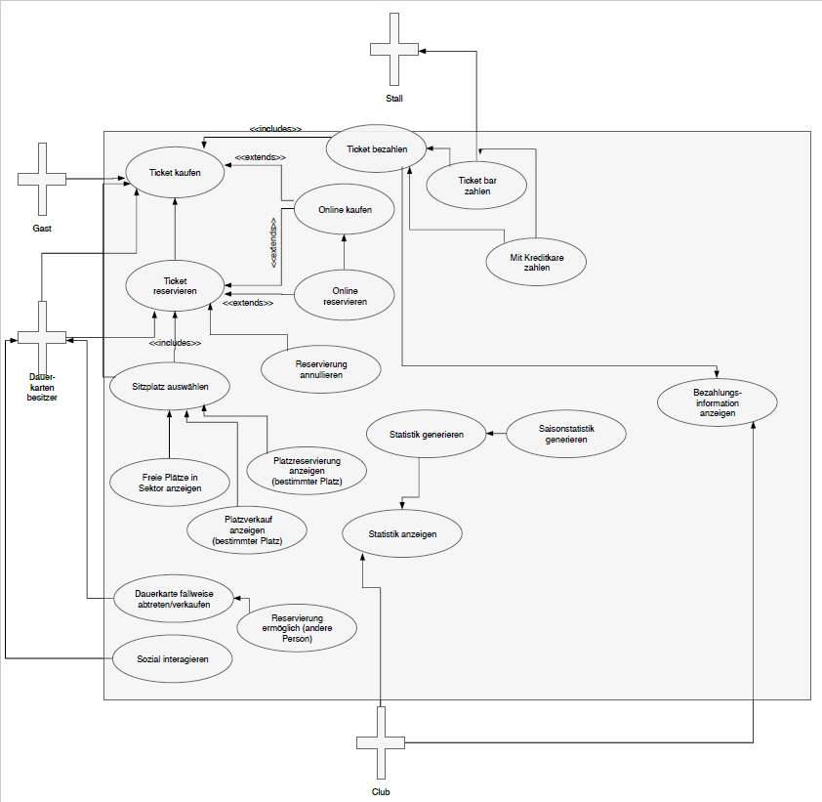

# Domain Model (CDM) and Descriptions

# Selected Technology

Java Enterprise Edition

# System Architecture, Component Diagrams and Descriptions

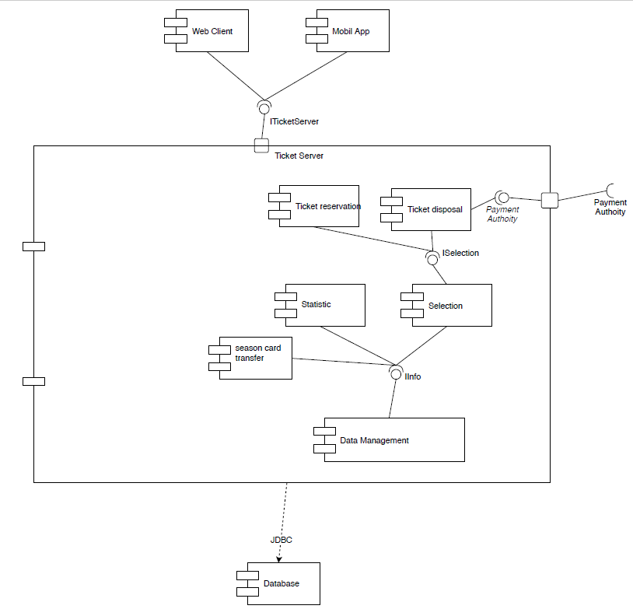

# Class and Sequence Diagrams

# Deployment Diagrams

# Implemented System

# Conclusion (What was reached / not reached. Next steps)